Visualizing And Predicting Heart

Diseases With An Interactive

Dashboard

**ABSTRACT :**

The healthcare data can be employed to develop a health prediction system that can improve in heart disease prevention. Big data on health care, including patient records, clinical notes, diagnosis, parents and family past ailments, hospitals, and scan results can aid in the phase of disease identification and prediction. The emerging machine learning method offers an important framework for forecasting cardiac diseases. An advanced Support Vector Machine (SVM) classifier was used by the program to conduct parameter tuning to improve classification accuracy and performance. The methodology of this research is applying parameterization for parameters on SVM to make the possibility of prediction is higher using the most effective features.

**INTRODUCTION :**

* There are currently several researchers who have developed machine learning approaches for the early detection of chronic diseases.
* Big data analysis in healthcare is very convenient and useful to use technology to produce medical data with spark and machine learning algorithms to predict health problems.
* Information systems are generally concerned with providing information for use in the organization, and today it took a new organized dimension where it became treated as a resource of organizational resources.
* Health information systems and technology have brought distances far beyond human reach, and have enabled the storage of digital, text, audio, and image data.
* The General Directorate of Hospitals is responsible for organizing the work of hospitals and monitoring the performance and providing the necessary means while regulating the relationship with other departments in the Ministry of Health. Parallel Management aimed at integrating work among all hospitals, distributing competencies and manpower.

**DESIGN :**

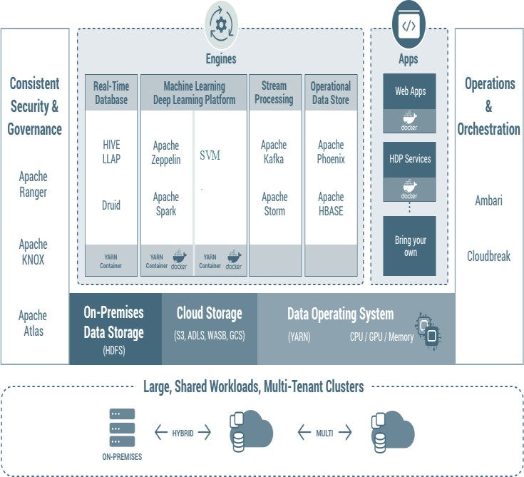

**Implementation and experimental testing :**

* The target of the testing is to show the efficiency of the system using Microsoft Azure. The system is being trained using a Microsoft cloud framework to make use of the power of the cloud architecture in processing the streaming data.
* We developed a heart disease classification model using the following characteristics as input features: sex, type of chest pain, age, blood pressure resting, serum cholesterol, max heart rate, EEG resting, exercise-induced depression angina, blood sugar rate, training style, and some of the major vessels.

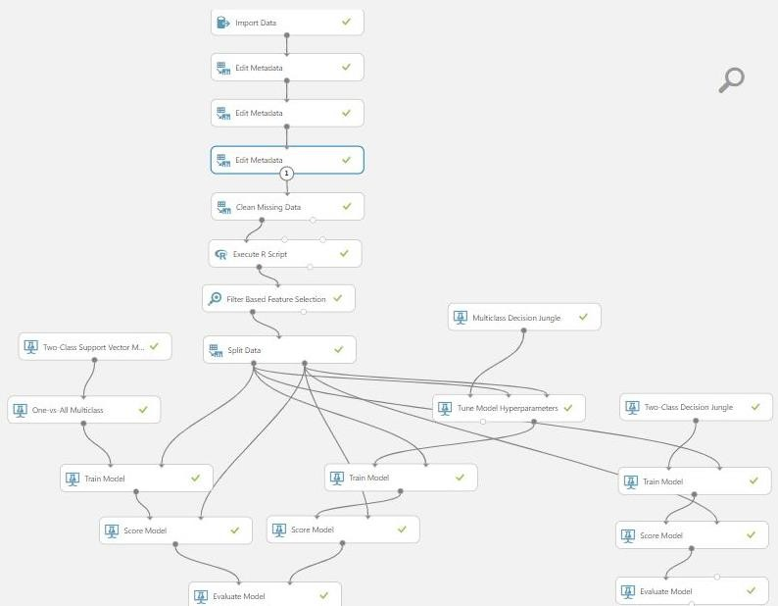

# Discussion :

The need for applying machine learning algorithms on available large medical data rather than traditional methods became one of the most driving research topics in healthcare. The article presented mainly an efficient architecture to work with streaming data from different wearable devices in the healthcare systems. The proposed healthcare system employs Microsoft Azure instead of using a standalone server to work with streaming data.

# Conclusion and Future work :

The program approach offered a broad computer structure that manages EHR computer focused on streaming data from connected medical devices and patient history for patients. This paper provides an important approach for the health prediction method utilizing the EHR platform and consumer social health profile information exploration methods. The proposed framework also offers an efficient way to link Spark and Microsoft Azure-based streaming data from wearable devices to forecast diseases. Future research is to apply this theoretical program to its data utilizing deep learning techniques. The next phase of our proposed research is to include a cloud framework that supports the dataset of records of the disease.

**REFERENCES:**

* J. Archenaa, A.Mary, "Health recommender system using big data analytics.", J. Manage. Sci. Bus. Intell. Pp. 17-24, 2017.
* A.Ismail, A. Shehab, I. El- Henawy, “Healthcare Analysis in Smart Big Data Analytics: Reviews, Challenges, and Recommendations”, In Security in Smart Cities: Models, Applications, and Challenges, Springer, Cham, pp. 27-45, 2019.
* L. Nair, S. Shetty, “Applying spark-based machine learning model on streaming big data for health status prediction”, Computers & Electrical Engineering, vol 65, pp. 393-399, 2018.
* A. Ismail, A. Shehab, I. El- Henawy, L. Osman, M. Elhoseny, “Quantified self-using IoT wearable devices”, In International Conference on Advanced Intelligent Systems and Informatics”, Springer, pp. 820-831, 2017.
* G. Manogaran, D. Lopez, “Health data analytics using scalable logistic regression with stochastic gradient descent”, International